Extraction and Analysis of Massive Data- (Data Mining)

Hemant Ravi1,Stuti Mohan Srivastava2, Vasudev Gupta3, Karthikeyan P4

Department of Computer Applications, School of Information Technology & Engineering,

Vellore Institute of Technology

#1 hemant.ravi2019@ vitstudent.ac.in, #2 [stutimohan.srivastava2019@vitstudent.ac.in,](mailto:stutimohan.srivastava2019@vitstudent.ac.in)

#3 [vasudev.gupta2019vitstudent.ac.in ,](mailto:vasudev.gupta2019vitstudent.ac.in%20,%20) #4 [pkarthikeyan@vit.ac.in](mailto:pkarthikeyan@vit.ac.in)

# Abstract

Data mining, are methodology in which discovers ways from excessive measure of information. The content is all about of the data mining procedures, counts and a bit of the affiliations which have balanced data mining development to improve their associations and found splendid results.

Data Mining is a way that helpful patterns from great amount of knowledge. The content discusses about the data mining techniques, algorithms and some organizations that have tailored data mining technology to upgrade their business and have achieved wonderful results.

In this paper we are going to study and analyze and review various advancements in the field of data mining and we will focus on challenges andissues which are currently remained unresolved.

**Keywords-**DMT (Data Mining Techniques) Architecture of Data Mining, Data Mining Procedures, KDD (Knowledge Discovery Database).

1. INTRODUCTION

The advancement of Information Technology has produced enormous measure of databases and immense information in different zones. The exploration in databases and data innovation has offered climb the best approach to manage store what's more, control this valuable information for upcoming basic leadership. Information mining is a procedure of

Extraction of helpful data and examples from Enormous information. It is likewise called as information disclosure process, learning Mining from information, information extraction or information/design examination. Data mining is an intelligent procedure that is utilized to look through huge measure of information so as to discover valuable information. The objective of this method is to discover designs that were beforehand obscure. Once these examples are discovered they can further be utilized to settle on specific choices for improvement of theirorganizations.

According to William J.Frawley, Data Mining refers to "The non-trivial extraction of implicit, previously unknown, and potentially useful information from data" [9].

**Steps involved in Data Mining – Investigation -** In the first steps of exploration, information is clean and also changed into some another structure, and significant factors.

**Pattern Identification -**When information are investigated, and characterized for the particular factors that subsequent advance is to shape design distinguishing proof. Recognize andpick the examples which make the bestforecast.

**Deployment-**Examples are conveyed for wanted result.

**Fig.** 1.1 – Knowledge Discovery Process

It is the essential part of the knowledge Discovery Process. The Knowledge Discovery in databases (KDD) procedure is usually characterized [2]

1. Selection
2. Pre-processing
3. Transformation
4. Datamining
5. Interpretation/evaluation

In any case, in a few minor departures from this topic, for example, the Cross-Industry Standard Process for Data Mining (CRISP-DM) that defines six phases:

1. Understanding perceptive of Business
2. Data Overview
3. Data-preparation
4. Modeling tool
5. Evaluate data
6. Deployment

Some simplified process is:-

1. Pre-processing
2. Data-Mining
3. Validation Result.

Basically, Cross-industry standard procedure for Data mining, known as CRISP-DM, is an open standard procedure model that portrays normal methodologies utilized by data mining specialists. It is the most broadly utilized analytical model. Figure 1.1 illustrates the procedures below-

**Pre-Processing**

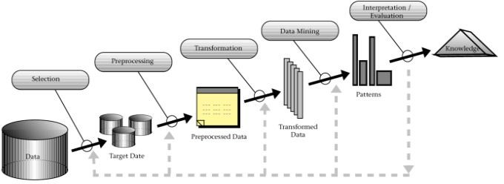Before information mining figuring’s can be used, a target information accumulation must be assembled. As information mining can simply uncover structures truly present in the data, the objective data collection must be enormous enough. While staying compact enough to be mined inside a satisfactory time limit. An ordinary hotspot for information is an information spot or information distribution center. Pre- processing is fundamental to separate the multivariate educational files before information mining.. Now, objective set data is clean. Information cleaning ousts the recognitions containing upheaval and those with missing data.

**Data Mining**

It includes 6 basic tasks:

**Abnormality Detection (exception discovery)** – A distinguishing proof of unordinary information records, that may premium or information blunders that require further examination.

**Affiliation Rule learning (reliance demonstrating)** – Scans for connections between the factor. For instance, a store may accumulate information on client buying propensities. Utilizing association rule learning, the grocery store can figure out which items are as often as possible purchased together and utilize this data for showcasing purposes.

**Clustering** – It is an assignment of searching gatherings and structures in the data that are by one way or another or another or another.

**Classification-** It is the undertaking of summing the structure designed to apply to new information. An instance, an email programming may endeavor to make an order through an email as "authentic" or “spam".

**Regression** –It endeavors to a discovered a capacity which holds the information with the few mistake that’s, used for a evaluating the connections between an information and datasets.

**Summarization** – It gives a progressively reduced portrayal of the collected data, also includes representation and reporting data.

**Validation Result -** Data mining is can be misused unintentionally and would then be able to produce outcomes that are worthy of note; however, which don't really anticipate future conduct and can't be repeated on alternative way on of data and bear little use. Frequently that outcome exploring from an excessive number of theories and not performing legitimate measurable speculation testing. A straightforward variant of this issue in AI is known as overfitting, however a similar issue can emerge at various periods of the procedure and along these lines a train/test split - when pertinent by any stretch of the imagination-it may not be appropriate to keep this from occurring.

An end feet’s of information revelation basically from a data is for checking that the delivered by the data mining calculations happen in such a more extensive informational index. Not all e.g. found by the data mining calculators, which are fundamentally legitimate. It is causal for data mining calculations to discover designs in the preparation paper set that are absent in the informational collection. This is called as over fitting. To separate that, an assessment utilizes a test which is a set of data mining.

Calculation wasn’t prepared. The subsequent yield is a contrasted with the unique yield. For a instance, a data mining calculation attempting for recognize "spam" from "authentic" messages, that would be prepared on a preparation of a test messages. When prepared, the educated way would be applied to the test set of messages on which it had not been readied. Various measurable strategies might be utilized to assess the calculation, for example, ROC bends/curves.

On the off chance that the scholarly examples don't fulfill the ideal guidelines, in this manner it is important to reconsider and furthermore, change the pre-planning and data mining steps. In the event that the scholarly examples do satisfy the ideal guidelines, at that point the last advance is to decipher the educated examples and transform them into information.

**II.DATA MININGTECHNIQUES**

Extricating significant information from a lot of information can be vital to associations for the procedure of basic leadership. Some Data Mining Techniques are–

# Association

Association Technique discovers the example from colossal information, in light of a connection between at least two things of a similar exchange. The association technique is utilized to break down market implies it help us todissect individuals' purchasingpropensities.

For instance, you may distinguish that a client consistently purchases ice-cream at whatever point he comes to watch movie so it may be conceivable that whenclient again

Comes to watch movie he may likewise need to purchase frozen ice-cream once more.

# Classification

Classification method is most regular data mining strategy. In arrangement strategy we utilize numerical systems, for example, decision trees, neural system and measurements so as to anticipate obscure records. This procedure helps in determining significant data about information.

For example, let’s consider you have set of tuples, each tuple has a set of attributes and relying upon these attributes you will be able to anticipate unseen or unknown tuples. For example, you have given all records of workers who left the organization, with classification technique you can anticipate who will probably leave the organization in a futureperiod.

# Clustering

Clustering isperhaps the most seasoned system utilized during the time spent data mining. The fundamental point of bunching system is to makes cluster (groups) from bits of information which offer regular attributes. Clustering Technique help to distinguish the distinctions and likenesses between the information.

For instance, take an example of a shop in which many items are for sales, now the challenge is how to keep those items in such way that customer can easily find his required item. By using the clustering method, you can have some objects in one corner that have same similarities and other objects in another corner that have some differentsimilarities.

# Sequentialpatterns

Sequential patterns are a useful method for identifying trends and similar patterns.

For example, in customer data you identify that a customer buys particular product on particular time of year, you can use this

information to suggest customer these particular products on that time of year.

# Decision tree

Decision tree is one of the most well-known utilized information mining methods since its model is straightforward for clients. In choice tree you start with a straightforward inquiry which has at least two answers. Each answer prompts a further at least two inquiries which help us to settle on an official choice. The root hub ofchoice tree is a straightforward inquiry. Figure2.1 illustrates the aboveprocedure.

Take an example of flood warning system:

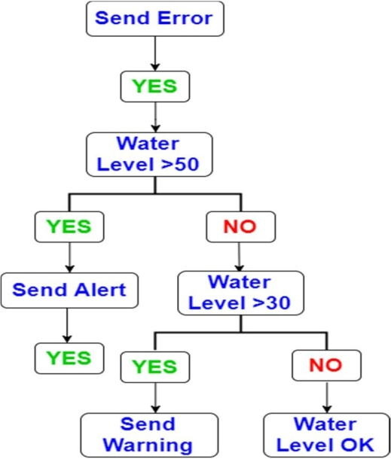

**Fig. 2.1** – Decision Tree

III. RELATED TECHNOLOGIES

# Machine Learning vs. Data Mining

1. Large data sets in Data Mining
2. Productivity of algorithm are essential.
3. Scalability of algorithm
4. True Data
5. Missed Values
6. Pre-defined data
7. Data are not constant
8. Proficient techniques for information recovery accessible for use.
9. Domain Knowledge in the form of integrity constraintsavailable

# Data Warehousing

It is fundamentally a concentrated information store which can be requested for business benefits. Information warehousing makes it adaptable and agreeable to conquer irregularities between various heritage information formats by coordinating information all through an undertaking paying little mind to area, arrangement or correspondenceprerequisites.

**OLAP (On-line Analytical Processing)** it’s a class of a programming makes that an enables clients go to break down data from various database frameworks simultaneously. It is an innovation that empowers experts to concentrate and view business information from various perspectives. OLAP represents OLAP. Experts habitually need for gathering, total and join information..

With OLAP information that can be pre-defined and pre-collected, that makes investigation quicker.

Its databases are differentiate into many cubes forms. That cubes are mainly designed in such a criteria that creating and seeing reports become easy. It is illustrated in Fig.3.1

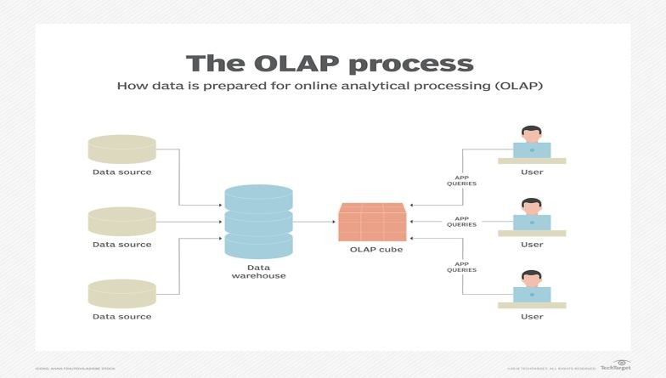

**Fig. 3.1** The OLAP Process

Multi – dimensional Data Model (data cube) Operations

**Roll*-*up** also called as “Consolidation” and also“aggregation”. The operation can be implemented in 2 different types:-

Diminishing dimensions

Climbing up concept hierarchy. It is defined as a system of collecting of things according to their level of order.

**Drill- Down**

In this, it is used to fragment into smaller segments. It is vice versa of the rollup process, which can be implemented through going down the previous hierarchy by increasing a measurements.

# Slice

Here, one dimension is used, and a new formation of sub- cube is made.

# Dice

Dice is same as a slice. The distinction in dice is that select a pair that result in the creation of a new form of a sub-cube.

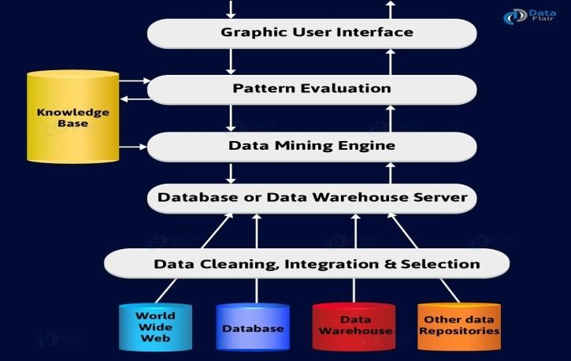

**Fig. 3.2** Data Mining Architecture

Data mining Architecture framework contains such a large number of segments. That isa data source, data distribution warehouse server, data mining engine, and knowledgebase.

# Data Sources

There are so many documents present. That is a database, data warehouse, World Wide Web (www). That are the actual sources of data.Sometimes, information could reside even in plain text files or spreadsheets. World Wide Web or the Internet is another massive source ofdata.

# Data Warehouse server

The database server contains the genuine information that is fit to be prepared. Henceforth, the server handles recovering the significant information. That depends on the information mining solicitation of the client.

# Data Mining Engine

In data mining framework, engine is the main segment. As it comprises different modules that used to perform data mining operation. That incorporates affiliation, arrangement, Portrayal, grouping, expectation, and so forth.

# Pattern Changement Models

This is basically answerable for the proportion of a intriguing quality. For that, we basically utilize edge esteem. Likewise, it communicates with the information mining motor. That is primary center is to look towards intriguing examples.

# Graphic User interfaces

Basically utilizing this particular interface is to convey a message between the client (sender) and the data mining framework system. Additionally, a module enables the client to utilize the particular framework effectively and productively. They don't have the foggiest idea about a genuine unpredictability of the procedure. At the point when the client indicates an inquiry, this will communicates with data mining framework. Consequently, shows a outcome in an effectively justifiable way.

# Knowledge Base

The entire data mining procedure, this is helpful. We acquire it to manage the quest for that outcome designs. This may even contain client convictions and information from client encounters, which can be helpful during the time spent data mining. The data mining engine may get a involment from the knowledge. This make the base outcome progressively precise and solid. The example assessment part communicates with an information base.

**IV. CHALLENGES IN DATA MINING**

After all it is very powerful, it faces many difficulty during its implementation. The challenges could be similar to the performance. The process becomes successful when the issues are identify correct and arranged it out properly.

**Overfitting –**Over fitting happens when the model doesn't fit future states. At the point when a data mining calculation looks for the best parameters for a particular model utilizing a lot of tests, it might over-fit the information, bringing about poor speculation. Cross-approval, regularization and other modern factual strategies can be applied to conquer theissue.

**Missing and Noisy Data -** Missing data are very normal. Overlooking cases with missing qualities frequently brings about lost data, which is in opposition to building up a decent information mining model. There are numerous factual techniques to manage missing data and recognize loud qualityqualities.

**Size of dataset -** at the point when datasets contains several fields andtables, a great many records and multi-gigabyte measured documents, it ishard to extricate information by a speedy mining task. Numerous calculations simply solidify during the preparation period of huge datasets. The databases are dynamic and their substance are continue changing as data is included, altered or expelled. The issue with this, from the point of view of information mining, is the means by which to guarantee that they are modern and predictable with the most presentdata.

**Outliers -** The data sections that don't fit pleasantly into the inferred model. That the

Model is built up that incorporates these exceptions, at that point the model may not carry on well for information that are not anomalies**.**

**High dimensionality** - This alludes not to an enormous number of records however to countless traits in a datasets-a typical circumstance with bioinformatics datasets where 30000 properties or more can exit. A high dimensional dataset makes issues regarding expanding the size of the quest space for a proficient model development to play out the information miningtask.

**Changing data and knowledge -** Quickly changing information may deceive the data mining clients on the grounds that the created models may wind up outdated before the application. Potential arrangements incorporate gradual strategies for refreshing examples.

1. **LITERATURE REVIEW**

A Bulk of work has been attempted in the field of data mining similar to living style disease diagnosis using different data mining techniques. A short description of two diseases and the work that has been done by severalauthors.

**Diagnosis using method called Classification in Heart Disease** - Hlaudi Daniel, Masethe anticipates and diagnose heart disease by data mining algorithms like j48, Reptree, Bayes Net, Simple CART. Accuracy of j48, Reptree, Bayes Net, Simple CART are 99.07%, 99.07%, 98.14%and 99.07% respectively [13].

**Prediction system using Clustering in heart attack** – Shanta Kumar B. Patil used K- mean clustering algorithm on the pre- handled information. What's more, the repetitive examples appropriate to coronary illness are mined with the MAFIA calculation by the data extraction. A neural system is prepared with the chose significant examples for compelling

Expectation of Heart Attack based on registered noteworthy weightage [24].

**Diagnosis using Fuzzy Logic Approach-** P.K. Anooj has proposed a fuzzy guideline based on CDSS for the determination of coronary illness. It automatically acquires the learning from the patient information. They proposed CDSS for a danger of heart patients which comprises into of two stages. First one is an electronic methodology for age of weighted fluffy principles and choice tree and the second one is making a fuzzy logic standard based on choice emotionally supportive network [21].

**Prediction using Association Rule -** V. Manikandan et al. separate the thing set relations by utilizing association rule. The information characterization depended on MAFIA calculations which brought about better precision. MAFIA (Maximal Frequent Item Set Algorithm)

Basically utilized a dataset with 19 qualities and the objective ofthe examination work was to have exceptionally exact review measurements with more significant levels of accuracy [25].

# Prediction using Hybrid system –

# R. Chitra et.al. Present Hybrid Intelligent strategies for the forecast of coronary illness.

# Some Heart infection grouping framework was audited in this examination and closed with defense significance of information mining in coronary illness analysis and characterization. The grouping precision can be improved by decrease in highlights [21].

**Type II Prediction using hybrid model-** Jayaram et al. create of a half and half model for characterizing Pima Indian Diabetic Database (PIDD). The model comprised of two phases. In the main stage, the K-implies grouping was utilized to recognize andwiped out erroneouslyclassified occurrences.

In the second stage a tweaked grouping was finished utilizing Decision tree C4.5 by taking the effectively bunched occurrence of first stage. Exploratory outcomes imply that fell K-implies grouping and the guidelines created by fell C4.5 tree with absolute information is anything but difficult to decipher when contrasted with principles produced with C4.5 alone with persistent information. The cascaded model with all out information got the classification accuracy of 93.33% [15].

**6. BASIC APPLICATIONS (DATA MINING)**

**1) In Marketing:** Data mining is a procedure to remove data from the different information source which is exceptionally helpful during the time spent arranging, sorting out, overseeing and propelling new item in a practical manner. Data mining system help us to comprehend the buy conduct of a purchaser like how oftentimes client buy a thing, all out estimation all things considered and when was the last purchase. With information mining you can comprehend the necessities ofpurchaser’s and make item and administrations as indicated by purchaser's prerequisite.

Database promoting is one of the most mainstream utilization of information mining.

**Data Mining Application in Health Care** Data mining can be valuable to improve human services system. With data mining you can anticipate number of patients which help you to ensure that each patient get legitimate consideration at ideal time and at idealspot.

Data mining can help all gatherings engaged with the social insurance industry. For model, information mining can help medicinal services guarantors recognize misrepresentation and misuse, human

Services associations can improve their basic leadership by utilizing learning given by data mining, patients can get better and increasingly reasonable human services administrations.

**Data Mining Application in Education** Educational Data mining (EDM) is another rising field which is utilized to address understudies’ difficulties and help us to see how understudies learn by making understudy models. The fundamental objective of instructive information mining is to foresee understudies’ future learning conduct with the goal that vital advances can be taken before an understudy falls or drops out. Data mining is additionally used to anticipate the consequences of the understudy [3].

# Data Mining Application in Retail Industry

Retail industry gathers enormous measure of information on deals and client shopping history. Retail data mining helps in examining customer conduct, client purchasing behaviors and patterns and lead to better client care, great consumer loyalty and limit the expense ofbusiness.

# Data Mining Application in Banking

The financial business has tremendously profited by the headways in advanced innovation. Information mining is winding up deliberately significant zone for some business associations including banking area.

Data mining is utilized in money related and banking division for credit examination, fake exchanges, money the board and to foreseeinginstallment.

# CRM

Customer Relationship Management is tied in with securing and holding clients, additionallyimproving clients' unwaveringness and actualizingclient

Centered systems. To keep up an appropriate association with a client a business needs to gather information and dissect the data. This is the place information mining has its influence. With information mining innovations the gathered information can be utilized for investigation. Rather than being befuddled where to center to hold client, the searchers for the arrangement get separated outcomes.

# Fraud Detection

Billions of dollars have been lost to the activity of cheats. Customary strategies for misrepresentation discovery are tedious and complex. Information mining helps in giving significant examples and transforming information into data. Any data that is legitimate and valuable is learning. An ideal misrepresentation location framework ought to secure data of the considerable number of clients. A managed strategy incorporates gathering of test records. These records are grouped deceitful or non-fake. A model is fabricated utilizing this information and the calculation is made to recognize whether the record is fake or not.

# Intrusion/Lie Detection

Any activity that will bargain the trustworthiness and privacy of an asset is an interruption. The cautious measures to maintain a strategic distance from an interruption incorporates client verification, abstain from programming mistakes, and data security. Information mining can help improve interruption discovery by adding a degree of center toirregularity identification. It causes aninvestigator to recognize a movement from normal ordinary system action. Data mining additionally helps extricate information which is increasingly significant to theissue.

Catching a criminal is simple though drawing out reality from him is troublesome. Law implementation can utilizemining

strategies to explore wrongdoings, screen correspondence of suspected fear mongers. This recorded incorporates content mining moreover. This procedure looks to discover important examples in information which is typically unstructured content. The information test gathered from past examinations are looked at and a model for falsehood discovery is made. With this model procedure can be made by theneed.

# Criminal Investigation

Criminology isa procedure that means to distinguish wrong doing attributes. All things considered wrongdoing investigation incorporates investigating and recognizing violations and their associations with lawbreakers. The enormous volume of bad behavior datasets and moreover the unusualness of associations between these sorts of data have made criminology an appropriate field for applying data mining frameworks. Content based wrongdoing reports can be changed over into word preparing records. These data can be utilized to perform wrongdoing coordinating procedure.

**7. DATA MINING TOOLS**

# R – Language

It is an open source tool and application for statistical and also for the graphics. It have a large classification of statistics, traditional factual, work on time-series analysis and graphical methods. It provide a data handling and storage capacity facility.

# Oracle Data Mining

It’s popularly knowns as ODM is a part of the Oracle Advanced Analytics Database [10]. This Data mining device causes information experts to make expounded bits of knowledge and makes expectations. It foresees client conduct, creates

Customer profiles, and recognizes cross- selling opportunities.

**IBM SPSSModeler**

When it comes to large-scale projects IBM SPSS Modeler turns out to be the best fit. In this modeler, text analytics and its state-of- the-art visual interface prove to be extremely valuable. It helps to create data mining algorithms with negligible or no programming. It can be widely used in anomaly detection, Bayesian networks, CARMA, Cox regression and basic neural networks that use multilayer perceptron with back-propagation learning.

# Rattle

It is an open free programming bundle providing a GUI for data mining by using R language issued by person called Togaware. It provides considerable data mining functions by expose the power of the R language through a GUI. It is also used for educational purposes . There is an alternative option called as Log Code tab, which replicates the R code for any activity in the GUI, which can be used for copy and paste. It allows for the dataset to be fragment into training, validation and testing.

# Conclusion

The size of massive data is booming across the globe at an alarming rate day by day with every passing minute. Data Mining is turning into the new zone for logical information inquire about and for business applications. Huge information examination is getting to be imperative for programmed finding of knowledge that is engaged with the every now and again happening examples and concealed guidelines. Huge information examination causes organizations to take good way, for foresee and recognize changes and to

Distinguish different chances. In this, we examined about the difficulty and moves identified with huge data mining.

This paper provides anoverview on data mining, the analysis includes data mining architecture, issues regarding in this fields that the techniques used for solved these challenges that applications and the tools used in data mining, websites, search engines, stock exchange markets and so on. The amounts of data are increasing at an alarming rate due to the explosure of social communication sites, finding and reagain processing of engines, media sites, stock trading, and news information and so on. Big Data is turning into the new area for examining scientific data and for business applications. Data analysis is now the key for finding intelligence that is occuring in the frequently patterns and hidden rules and regulation.It helps organizations to choose good and innovative options, to anticipate and recognize changes and to identify new changement opportunities. Athough we have discussion about the difficulity, challenges, related mining technologies, some of the various works which have been researched till now.

8. REFERENCES

1. A Dutt, M. A. Ismail, and T. Herawan, “A Systematic Review on Educational Data Mining,” vol. 3536, no, c, 2017.
2. A. E. Youssef, A framework for secure healthcare systems based on big data analytics in mobile cloud computing environments, International Journal of Ambient Systems and Applications, vol. 2, no. 2, pp. 1–11,2014.

[3] A. O’ Driscoll, J. Daugelaite, and R.D. Sleator, “Big Data”, Hadoop and cloud computing ingenomics, Journal of

Biomedical Informatics, vol.46, no.5, pp.774– 781, 2013.

1. B. Sarala Devi, N. Pazhaniraja, P. V.Paul,

M. S. Basha, and P. Dhavachelvan, Big data and Hadoop-A study insecurity perspective, Procedia Computer Science, vol.5 0, pp.596– 601,2015.

1. C.L.P. Chenand C.Y. Zhang, Data- intensive applications, challenges, techniques and technologies: A survey on big data, Information Sciences, vol. 275, pp. 314–347,2014.
2. D. H. Shin and M. J. Choi, Ecological views of big data: Perspective and issues, Telematics and Informatics, vol. 32, no. 2, pp. 311–320, 2015.
3. D.C. Anastasiu, J. Iverson, S. Smith, G. Karypis, Big data frequent pattern mining Frequent Pattern Mining, Springer, Cham (2014), pp.225-259.
4. D.P. Augustine, Leveraging big data analytics andHadoop in developing India healthcare services, International Journal of Computer Applications, vol.89, no. 16,pp

.44– 50, 2014.Data mining: an overview from a database perspective. IEEE Trans. Know. Data Eng., 8 (6) (1996), pp.866-

883.

1. Gandomi and M. Haider, Beyond the hype: Big data concepts, methods and analytics, International Journal of Information Management, vol. 35, no. 2, pp. 137–144,2015.
2. H. Mannila, H. Toivonen, A. InkeriVerkamo, "Efficient Algorithms for Discovering Association Rules”, Proc. AAAI Workshop Knowledge Discovery in Databases, pp. 181-192,1994-July.
3. Hlaudidanielmasethe, Mosimaannamasethe, “Prediction of heart disease using classification algorithms”, proceedings of the world congress on engineering and computer science 2014 vol. wees 2014, 22-24 October, 2014, San Francisco, USA.
4. J. A. Patel and P. Sharma, Big data for better health planning, in Proc. International Conference on Advances in Engineering and Technology Research, 2014, pp.1–5.
5. J.-S. Park, M.-S. Chen, P.S. Yu, "Mining Association Rules with Adjustable Accuracy", *IBM Research Report*, 1995.
6. Kaur & Singh, 2018; Ngai et al., 2009; Tamayo et al., 2005; Tsiptsis & Chorianopoulos, 2011.
7. M. Goebel andL. Gruenwald, “A Survey of Data Mining and Knowledge Discovery Software Tools,” SIGKDDExplore.News,vol.1,no.1,pp.20–33,1999
8. M. Herland, T. M. Khoshgoftaar, and R. Wald, A review of data mining using big data in health informatics, Journal of Big Data, vol. 1, no. 1, p. 2,2014.
9. M. Klemettinen, H. Mannila, P. Ronkainen, H. Toivonen, A.I. Verkamo, "Finding Interesting Rules from Large Sets of Discovered Association Rules", Proc. Third Int'l Conf. Information and Knowledge Management*,* pp. 401-408, 1994-Nov.
10. P. K. Anooj, “Clinical decision support system: risk level prediction of heart disease using weighted fuzzy rules”, Journal of computer sciences, vol.24, pp.27-40, 2012.
11. R. Chitra, “Review of heart disease prediction system using data mining and hybrid intelligent techniques”, intactjournal

On soft computing, July 2013, volume: 03, issue: 04.

[20] R. MehmoodandG.Graham, Bigdatalogistices: A healthcare transport capacity sharing model, Procedia Computer Science, vol. 64, pp. 1107–1114, 2015.

[21]S.Sharmaand, V.Mangat, Technologyandt rendstohandle big data: Survey, in Proc. 5th International Conference on Advanced Computing and Communication Technologies, 2015, pp.266–271.

1. Shantakumarb. Patil, “Extraction of significant patterns from heart disease warehouses for heart attack prediction”, international journal of computer science and network security, vol.9, no. 2, February.
2. W. Klsgen, "Explora: A Multipattern and Multistrategy Discovery Assistant", *Advances in Knowledge Discovery and Data Mining*, pp. 249-271, 1996.
3. X. Wu, X. Zhu, G. Q. Wu, and W. Ding, Data mining with big data, IEEE transactions on Knowledge and Data Engineering, vol. 26, no. 1, pp. 97–107, 2014.
4. Yazdani a, Ebrahimi t, Hoffmann u. (2009), “Classification of eeg signals using dempstershafer theory and a k-nearest neighbor classifier”, IEEE. In proc of the 4th intembsconfon Neural Engineering, pp. 327-30.